Does It Pour Out?

Time Frame: 15 minutes

Overview: In this activity, students will explore how gravitational and electrostatic forces affect water in different situations.

Standards and Objectives:
- ICP.3.1. Describe how we use macroscopic properties of matter to model microscopic processes: Students will be able to explain that electromagnet forces outweigh gravitational forces in a macroscale model with water and test tubes, and make the connection to the nanoscale.
- NS.3. Learners will be able to explain why (intensive) properties of matter can change at the nano-scale: Students will be able to explain that the electromagnetic force between the water molecules is stronger than the gravitational force when working on a smaller scale.

Preparation: Have the materials for the lab ready at each table.

Lesson:
- Students will be given two plastic test tubes, one large and one small. They will fill each with water and then predict what will happen when they turn them upside down. Make sure students predict before doing!
- Once they have observed what happens to the water (the water in the small test tube does not come out when turned upside down), students should answer the questions on the worksheet.
- After everyone has had a chance to do the lab and answer the questions, the teacher will lead a discussion about the students’ observations (see student worksheet)
- What differences do you notice between how the water pour out of the large test tube versus the small test tube?
- How does the shape and size of the container affect whether or not liquids pour out from the containers?
- What do you think is the reasoning behind the observations you are making?
  - How does this activity relate the gravitational vs. electromagnetic activity?
- How would you connect the observations made in this activity to the nanoscale?
- Geckos are able to walk upside down, against gravity, on many different substances since their feet are made up of millions of nanostructures called setae. How do electromagnetic forces play a role in this phenomenon?
- How does this concept relate to the concepts we have covered so far (size and scale and surface-area-to-volume ratio)?
Facilitation:
- During the lab, make sure students make a prediction about what will happen to the water before turning the test tubes upside down.
- Students may not recall much about electrostatic and gravitational forces from their science classes, or they may not have learned it yet. Therefore, after the activity, the teacher will need to explain some of those science concepts. An explanation is given in the Appendix of this lesson plan.

Assessment: The teacher can use the student worksheet to gauge student understanding. Also, in the Activity Log, students will be asked to write what they learned about nanotechnology and how it relates to their project.

References:
- http://nanosense.sri.com/activities/sizematters/properties/SM_Lesson3Student.pdfhttp://nanosense.sri.com/activities/sizematters/properties/SM_Lesson3Student.pdf
- http://teachers.stanford.edu/activities/PourItOut/PourItOut-TeacherGuide.pdf
- http://www.sciencepartners.info/?page_id=430 (structure of water visual)
- http://water.usgs.gov/edu/waterproperties.html (cohesion/adhesion explanation and visuals)
- Jones, M.G., Falvo, M.R., Taylor, A.R. & Broadwell, B.P. (2007). Nanoscale science: Activities for grade 6-12. National Science Teacher Association. 89-94.

Appendix: Explanation of electromagnetic (or electrostatic) and gravitational forces
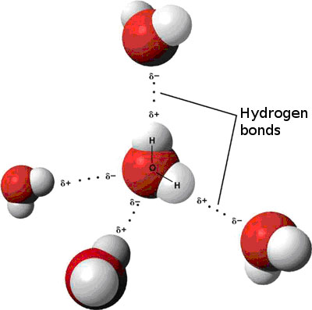
Electrostatic forces involve the interaction between the charges of two objects. Sometimes those objects have permanent charges such as a sodium ion (Na⁺¹) or chloride ion (Cl⁻¹). Other times molecules are electrically neutral but the distribution of charge within the molecule is not even and this leads to charge build up in one part of the molecule. This is called a dipole moment and these molecules are considered polar. The partially negative part of that molecule is attracted to the partially positive part of the surrounding molecules. In the case of water (H₂O), the oxygen is partially negative (δ-) so it is attracted to the partially positive (δ+) hydrogens of other water molecules. The attraction of these water molecules to each other is called van der Waals attraction. This interaction can be seen in the figure to the right.
Two properties of water include cohesion and adhesion. Cohesion is the attraction of water molecules to other water molecules. Cohesion can be observed through the clumping of water to make droplets, as seen in the picture on the left below. The cohesive force between water molecules causes the surface tension. An example of surface tension is the ability of small insects to walk on top of water. Adhesion is another property of water. Adhesion is the attraction of water to other substances. An example of this is water sticking to the end of pine needles as seen below on the right.
